|  |
| --- |
| USAF AcademyDepartment of Electrical and Computer EngineeringECE 281 Graded Review #1 Spring 2016 |
| |  |  |  |  | | --- | --- | --- | --- | | **Name:** |  | **Section:** |  | |
| |  |  | | --- | --- | | **Academic Security** | This examination is not released from academic security until **1630** on **16 February 2016**. Until this time, you may not discuss the examination contents or the course material with anyone other than your instructor. | | **Integrity** | Your honor is extremely important. This academic security policy is designed to help you succeed in meeting academic requirements while practicing the honorable behavior our country rightfully demands of its military. Do not compromise your integrity by violating academic security or by taking unfair advantage of your classmates. | | **Authorized Resources** | Calculator | | **Instructions** | * **Show all work for full credit** * Box or circle your final answer. * For all numerical answers, use engineering notation and include units. * Completely label all your diagrams, drawings, graphs, etc. for full credit. * You have **53 minutes** to complete this exam. |  |  |  |  | | --- | --- | --- | | **Problem** | **Value** | **Earned** | | 1 | 20 |  | | 2 | 20 |  | | 3 | 18 |  | | 4 | 16 |  | | 5 | 6 |  | | 6 | 20 |  | | Total | 100 |  | |

This page intentionally left blank.

|  |  |  |  |
| --- | --- | --- | --- |
| **Problem 1** | (20 points) | *Number Conversions* |  |

1. (2 points) Using 2s complement representation, the range of numbers you can represent with eight bits is:

b. (3 points) Convert 1111012 to hexadecimal. Show your work.

a. 75 b. 3D c. E1 d. 61 e. none of these

c. (3 points) Convert 10110 to octal. Show your work.

a. 131 b. 145 c. 65 d. 61 e. none of these

d. (3 points) Convert 10101102 to decimal. Show your work.

1. 108 b. 29 c. 56 d. 86 e. none of these

e. (3 points) Convert 2716 to binary. Show your work.

a. 011011 b. 101010 c. 100110 d. 010111 e. none of these

f. (3 points) Convert -2510 to 6-bit 2s complement binary. Show your work.

a. 100111 b. 111001 c. 011001 d. 010101 e. none of these

g. (3 points) Convert -2510 to 6-bit signed magnitude. Show your work.

a. 110101 b. 011001 c. 111101 d. 100111 e. none of these

|  |  |  |  |
| --- | --- | --- | --- |
| **Problem 2** | (20 points) | *Boolean Equations and Algebra* |  |

a. (4 points) Which expression is the most simplified form of $X+Y(Z+\overline{X+Z}$)?

1. 0
2. 1

$X+Y$

$X+YZ$

$X+YZ+Y\overline{XZ}$

b. (3 points) Given that: F(A, B, C) = $\overline{A}BC+\overline{B\overline{C}}+BC$, what does F(1, 1, 0) equal?

i. 0 ii. 1 iii. C iv. $\overline{C}$ v. none of these

c. Answer the following questions for this truth table.

|  |  |  |  |
| --- | --- | --- | --- |
| X | Y | Z | L |
| 0 | 0 | 0 | 0 |
| 0 | 0 | 1 | 0 |
| 0 | 1 | 0 | 1 |
| 0 | 1 | 1 | 1 |
| 1 | 0 | 0 | 1 |
| 1 | 0 | 1 | 0 |
| 1 | 1 | 0 | 0 |
| 1 | 1 | 1 | 1 |

1. (4 points) Write the Boolean equation for this truth table in SOP form.

L = ___________________________________________

1. (4 points) Write the SOP in simplified form.  
     
   L = ___________________________________________

d. (5 points) Darth Vader will enjoy his picnic on sunny days that have no ants. He will also enjoy his picnic any day he sees a humming bird, as well as days where there are ladybugs but no ants. Write a Boolean equation for his enjoyment (E) in terms of sun (S), ants (A), hummingbirds (H), and ladybugs (L).

|  |  |  |  |
| --- | --- | --- | --- |
| **Problem 3** | (18 points) | *K Maps & Combinational Logic Implementation* |  |

1. (8 points) Simplify the following equation using a Karnaugh map:   
   F(A, B, C, D) = ∑(2, 4, 6, 8, 10, 11, 12, 14, 15)

Also, we **don’t care** when ABCD = 1101.



Simplified Boolean Equation: $Y=___________________________________$

1. Use DeMorgan’s theorem to simplify the following circuit so that its equation can be found by inspection (i.e do not leave any bubbles unpushed).  
   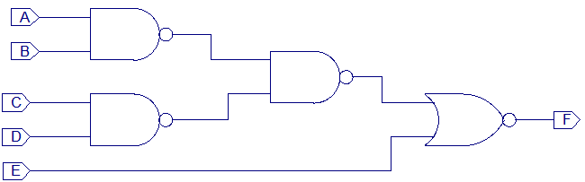
2. (8 points) Draw your final circuit below:
3. (2 points) Write the new equation for F (no need to simplify further from your schematic):   
     
   F = ____________________________________

|  |  |  |  |
| --- | --- | --- | --- |
| **Problem 4** | (16 points) | *Circuit Design* |  |

1. (16 points) Given two four-bit magnitude comparators, add some combinational logic gates and create an eight-bit magnitude comparator. Ensure the inputs (and associated bits) are clearly labeled. The outputs are shown on the left side of the page. (**Hint: How would a person compare two numbers?**)

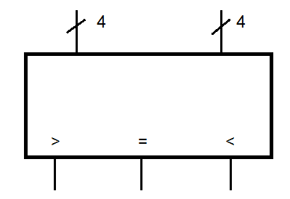 

>   
  
  
  
  
  
=  
  
  
  
  
  
  
<

|  |  |  |  |
| --- | --- | --- | --- |
| **Problem 5** | (6 points) | *Timing Analysis* |  |

Use the information in the below schematic and associated table to answer the next two questions.

|  |  |  |  |  |  |  |  |  |  |  |  |  |  |  |  |  |  |  |  |
| --- | --- | --- | --- | --- | --- | --- | --- | --- | --- | --- | --- | --- | --- | --- | --- | --- | --- | --- | --- |
|  | |  |  |  | | --- | --- | --- | | **Gate** | ***tpd*** | ***tcd*** | | AND | 30 | 25 | | OR | 30 | 25 | | NAND | 20 | 15 | | NOR | 40 | 20 | | XOR | 60 | 40 | |

1. (3 points) Draw the short path in the above schematic.
2. (3 points) Given the chart of gate delays in ps, calculate the length of the critical path. Show your work.

|  |  |  |  |
| --- | --- | --- | --- |
| **Problem 6** | (20 points) | *General Knowledge* |  |

Answer the questions below.

1. (3 points) The **primary** purpose for using git is:
   1. To connect with a website such as Bitbucket or GitHub
   2. To allow someone whose computer crashed to recover lost work
   3. To make miserable the lives of cadets unfamiliar with the command line interface
   4. To enable a person/team to revert to a previous version of code
2. (1 point each) Match the best associated description or example on the left with its term on the right.

|  |  |
| --- | --- |
| 1. _____ unit of data used by a particular processor 2. _____ product of two of the four inputs to a function 3. _____ not worrying about electrons when using OR gates 4. _____ logical equivalent of a function 5. _____ amount by which the output can vary and still be  considered a valid input 6. _____ bundle of signals 7. _____ sum involving all inputs to a functions 8. _____ interchangeable parts 9. _____ 8 bits 10. _____ single input change that causes multiple output changes 11. _____ each component has well-defined interfaces | 1. Abstraction 2. Discipline 3. Hierarchy 4. Modularity 5. Regularity 6. Byte 7. Nibble 8. Word 9. Overflow 10. Carry 11. Noise margin 12. Complement 13. Literal 14. Implicant 15. Dual 16. Minterm 17. Maxterm 18. Glitch 19. Bus |

1. (6 points) Explain the difference between a propagate and a generate signal as they pertain to an adder. Why are these signals useful? Give an example of a CPA that uses these signals in your description of their benefits.